

Gender Pay Gap Report 2021

Report of the Head of People and Organisational Development

Purpose of Report:
To report on the gender pay gap figures for the year ending 31st March 2021.

1. BACKGROUND

  - In April 2017, the government introduced a duty on employers with 250+ employees to calculate and publish six specific measures in relation to the pay gap between men and women in their organisation. Pay data is collected on a specific pay date – 31st March 2021 – and must be published on the national register by 31 March 2022.

  - This report reflects the pay analysis undertaken on pay data as at 31st March 2021 (for the year April 2020 to 31 March 2021).

  - This show that the gender pay gap has slightly decreased during the period.

2. REPORT

Gender Pay Gap Audit

2.1 The six specific measures collated are:

  - The difference in the mean hourly rate of pay
  - The difference in the median hourly rate of pay
  - The difference in the mean bonus pay
  - The difference in the median bonus pay
  - The proportion of male and female employees who were paid bonus pay
  - The proportion of male and female employees according to quartile pay bands

2.2 The outcomes from the audit are attached a mean hourly pay gap of 15.3%, and a median gender pay gap of 8.2%. This compares with a mean of 18.29% and a median average of 9.8% for 2019-20 – a reduction in both average and median pay between male and female employees i.e. the pay gap has reduced during 2020-21.

2.3 With the exception of On-call, average male pay is higher than average female pay. It should be noted that On-call pay represents a 12-week average. This may therefore reflect a short-term increase rather than a long-term pattern of higher hourly pay.

2.4 During 2020-21, the Service recruited an additional 17 women to the Service, compared to 31 men. Of these, two were to Wholetime roles, 3 to On-call roles and 12 to Support roles. This includes appointment to the Assistant Chief Fire Officer role in June 2020

2.5 It should be noted that the wholetime recruitment campaign saw an additional three women recruited to apprentice firefighter roles in April and September 2021, and these will be reflected in 2022 gender pay figures.

2.6 Quartile bandings are attached as Appendix A and reflect the greater number of men employed compared to women at each level of pay banding.

2.7 It should be noted that this pay gap does not indicate a disparity in hourly rate paid for men and women doing the same job, which is the same for men and women at NFRS, but rather reflects the gender balance within the workforce (83.87% male, 16.53% female) and the proportion of men in higher graded operational and managerial roles.

2.8 The table below shows the comparative pay gap differences calculated as a mean average, by work group:

Work group | Mean Average % | Nbr of women  (31 March 2020) | Nbr of men  (31 March 2020)
Whole-time | -6.14 | 29 (6.95%) | 388 (93.05%)
Support | -8.31 | 97 (54.5%) | 81 (45.5%)
On-call | +20.71 | 14 (5.55%) | 238 (94.44%)

2.9 The above figures reflect the fact the low number of women in operational roles (Whole-time and On-call), and whilst there are more women than men in Support roles, more men than women are employed in managerial or senior professional roles which accounts for the pay gap disparity.

2.10 This compares with a public-sector mean average of 14.5% and a median of 15.8% in 19/20. The Service is therefore above the public-sector average but significantly below the median figure.*1

2.11 In the private sector, the average mean pay gap was 22.1% and the median pay gap was 18.1% in 19/20. NFRS is below the private sector average and median figures.*

2.12 Overall, across all employers, the average mean pay gap was 15.5% in 19/20. The Service is therefore below the national average figure in 2020/21.

2.13 In terms of reducing the gender pay gap, the Service already has in place policies and pay structures that are reflective of best practice outlined in guidance documents. However, the lack of women in operational supervisory and senior management roles is a perennial issue and work needs to be undertaken to encourage more women to apply for higher graded roles. The gender pay gap will really only be closed by appointing more women to supervisory and managerial roles, and this requires more women to apply at entry level to wholetime and On Call roles.

2.14 The focus of actions to improve upon the gender pay gap are:

  - Undertake positive action to encourage more women to apply for Wholetime and On Call Firefighter roles;

  - Identify the reasons why more female fire-fighters do not apply for promotion and address any barriers/concerns;

  - Engage with the NFCC Direct Entry workstream;

  - Be pro-active in identifying those with the potential to progress to more senior roles and provide support and development;

  - Review any barriers for women to be appointed to senior roles across all work groups

  - Review the requirements of the On-call duty system to make it more attractive to female applicants

  - Provide opportunities for women to gain experience in higher level roles through temporary appointments, involvement in projects, development roles;

  - A mentoring scheme to be introduced to enable women in leadership roles within the service to provide advice to women who are interested in future development – mentoring and reverse mentoring is a part of this and should be extended to all female employees over time

  - Any additional flexible working arrangements that can be put in place, such as agile working.

  - Maintain engagement with the Nottingham City Future Leaders programme and encourage women to apply

2.15 The structure and gender profile of the Fire and Rescue Service provides particular challenges to closing the gender pay gap. It is a very hierarchical in terms of its opportunities for progression, which is underpinned by function and need for a command and control leadership style in operational situations. Over recent years, changes to our leadership development programmes have concentrated on a different leadership style based on coaching and effective people skills, which is also reflected in our selection processes, and this will change the culture of the service over time. This is more likely to attract women to leadership roles with the Service.

2.16 The need to recruit more women into entry level operational roles is key to addressing gender pay gap issues for the future. Positive action has gone some way to making a career with the fire service a more accessible option and we now have more women than ever before applying to and being successful at the recruitment stage. Recruitment campaigns will be run each year between 2022 and 2025 and this will provide an opportunity to engage with prospective female candidates to encourage them to apply for an apprentice firefighter role. It is important that this positive action is properly resourced and supported to enable this to continue.

2.17 Whilst progressing women within operational roles is key to impacting on the current gender pay gap, this is not to marginalise the need to recruit and develop more women into professional and leadership roles in support posts.

2.18 A Women’s Network group has become established during 2021, which provides support and guidance to women across the workforce, and is also a channel for women to raise issues. This group has made links to the women’s network (NEWS) in Nottinghamshire Police, with the aim of sharing good practice and events. The NFRS Womens Network is led by a champion from the Strategic Leadership Team to ensure engagement at the most senior levels of the organisation.

2.19 Currently, the majority of support roles are held by women (54.5%). There is a spread of grades which are fairly equally dispersed between men and women, however above Grade 8 men account for 58% of appointments (14.8% of all roles held by men compared to 8.25% of all roles held by women). This is likely to be linked to professional disparities, for instances in engineering, ICT and procurement roles, and the numbers of women qualified in those fields.

2.20 Whilst this is an educational rather than local issue, providing development opportunities could help women to progress, albeit there will be a cost associated with this – for instance, opening up graduate opportunities – or sponsoring current employees through academic qualification.

2.21 The work being undertaken by the NFCC through its direct entry and talent management workstreams is intended to support the sector as a whole to address issues of gender pay disparity, as well as diversity in general. It will be interesting to evaluate the impact of these schemes – as they are introduced locally – on diversity figures over the next few years. NFRS are engaged with both workstreams.

Tracy Crump
Head of People and OD
Appendix A – Quartile Salary Banding

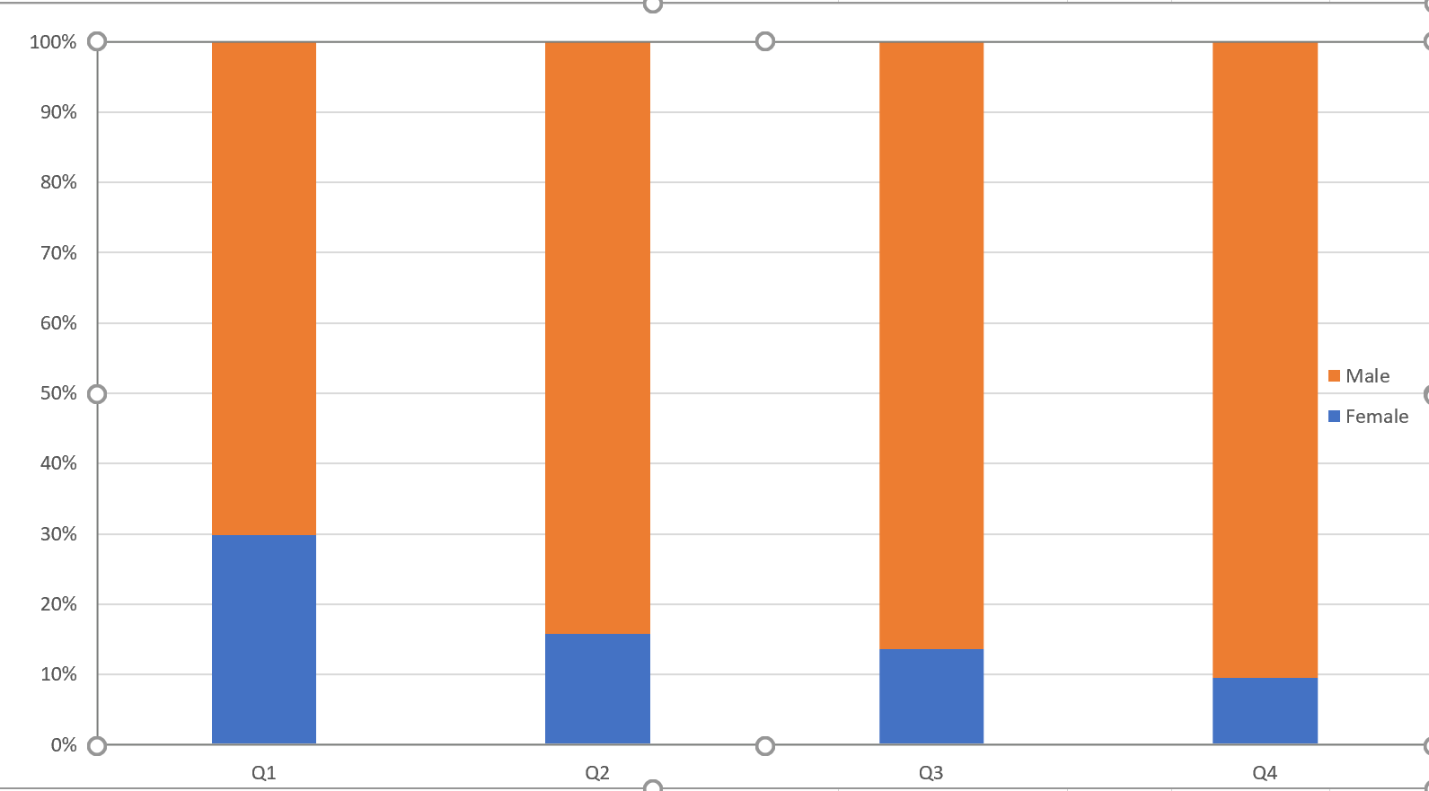

Hrly rate bands
£6.45 - £14.94 | Q1
£14.94-£16.69 | Q2
£16.69- £20.37 | Q3
£20.54-£72.79 | Q4

Source: Annual Survey of Hours and Earnings, Office for National Statistics.

