

September 2021

Nottinghamshire Fire Authority

Prepared by:

**Yunus Gajra**

Business Development Manager

Tel: 01274 432343

Mobile: 07582105760

Email: Yunus.gajra@wypf.org.uk

West Yorkshire Pension Fund

Aldermanbury House

4 Godwin Street

Bradford

BD1 2ST

www.wypf.org.uk

Follow WYPF on Twitter [www.twitter.com/wypf_lgps](http://www.twitter.com/wypf_lgps)

Follow WYPF on Facebook [www.facebook.com/westyorkshirepensionfund](http://www.facebook.com/westyorkshirepensionfund)







Contents

1 Regulations/Fire Scheme Update 4

2 Member Issues 6

3 Administration Issues 7

4 Key performance Indicators 8

4 Work in progress 9

5 Member web registrations 10

6 Calendar of Events 11

7 Membership Numbers 12

8 Five Year Audit Plan 16

9 Overriding Disclosure Time Limits 17

**1.0 Regulations/Fire Scheme Update**

1.1 SAB Bulletin

Please take a few minutes to read the Firefighters’ Pension (England) Scheme Advisory Board Bulletin (Link to Bulletin below) and take any action required.

[Bulletin 48](https://www.fpsregs.org/images/Bulletins/Bulletin-48-August-2021/Bulletin-48.pdf)

Items to highlight:

PSP&JO Bill Home Office guidance

Home Office guidance has now been published, following the announcement of the introduction of Public Service Pensions & Judicial Offices (PSP&JO) Bill and the accompanying centralised Q & A document in FPS Bulletin 47 – July 2021.

The PSP&JO Bill Home Office guidance is a more tailored version of the central FAQs for the FPS. It provides a detailed summary of how the Bill legislates to remove the discrimination identified in the McCloud/Sargeant litigation and what it means for affected scheme members.

For reference, it contains information on:

• what the Government has published;

• the background and detail of the Public Service Pensions and Judicial Offices Bill;

• how the Bill will implement changes across all the main public service pension schemes in response to the Court of Appeal judgment in the McCloud and Sargeant cases;

• the next steps following the Bill and any additional information which may be helpful to members. Please note that the guidance will be kept under review.

**LGA update on the PSP&JO Bill**

We are pleased to publish an LGA update on the PSP&JO Bill and what it means for the FPS.

The update comments on the main provisions of the Bill and looks in particular at the effect for transition members**.**

**SAB response to HMT consultations**

We told readers in FPS Bulletin 46 – June 2021 that HM Treasury (HMT) had published two public consultations seeking views on proposals to reform the cost control mechanism in public service pension schemes, and secondly on the appropriate methodology for setting the discount rate used in scheme valuations.

The Scheme Advisory Board (SAB) submitted responses to both consultations on 19 August, working closely with the Cost-effectiveness committee and the actuarial advisers to the SAB, First Actuarial.

The responses can be found on the consultations page of the SAB website.

**TPR publishes interim response to code of practice consultation**

Between 17 March and 26 May 2021, the Pensions Regulator (TPR) consulted on a proposed new code of practice. The first phase of the new modular code contains 51 topic-based units and replaces 10 of the longer existing codes of practice.

TPR published its interim response to the code of practice consultation on 24 August 2021. Key points or issues raised were support for setting common expectations of all schemes, the intended audience for modules, use of the new term ‘governing body’, and the requirement for schemes to undertake an own risk assessment.

TPR is currently reviewing the detailed feedback received and the earliest time that the new code might become effective is summer 2022.

**Information about completing and submitting a public service scheme return**

can be found on the TPR website. Schemes are advised to make sure that their contact details are up to date on the Exchange system.

Completing the scheme return is a legal requirement and scheme managers could be fined for failing to submit a completed return by the deadline

**Managing Pension Schemes (MPS) service**

On 16 August 2021, HMRC published Managing Pension Schemes service newsletter – August 2021. The latest newsletter has articles on:

• declaring as pension scheme administrator for a retirement annuity contract and deferred annuity contract

• submitting an Event Report

• migration

• Accounting for Tax (AFT) return

• how you can help us • signing into online services

• updating your details

1.2 Pensions Ombudsman update

**Overpayment cases in the public sector**

The Pensions Ombudsman (TPO) has recently made determinations on three complaints concerning overpayments made by public service pension schemes:

PO-28155 – Civil Service Pension overpaid between 2013 and 2018 because a transfer in was counted twice. TPO found that the overpayment could be recovered in full because:

* the scheme made a claim for recovery within six years of the overpayment first being made and
* TPO found that none of the defences against recovery applied.

TPO did partially uphold the complaint and awarded £500 for distress and inconvenience. This was because it took the scheme around five years to notice and deal with the overpayment and then asked the member to repay the full overpayment within 28 days.

PO-27694 – Teacher’s Pension in Scotland overpaid because the member exceeded the ‘salary of reference’ on re-employment. The teacher argued that the overpayment occurred because she had been provided with incorrect information by SPPA. TPO did not uphold the complaint and found that SPPA’s claim for repayment of the full overpayment was made within time and no defences against recovery applied. SPPA has offered £500 in recognition of distress and inconvenience related to delayed responses and delayed action to suspend the pension, which TPO found to be adequate.

CAS-30002-K6Z8 – Teacher’s Pension overpaid between 2014 and 2018 because service in respect of which a refund had been paid was wrongly included in the calculation of the pension. Teachers’ Pensions offered £500 for distress and inconvenience. TPO upheld the complaint in part based on a change of position defence. TPO directed Teachers’ Pensions to reduce the overpayment it is seeking to recover and to pay £1,000 for the serious distress and inconvenience. Teachers’ Pensions will recover the amount by which the lump sum was overpaid, but not the pension.

**2.0 Member Issues**

None

**3.0 Administration Update**

3.1 Remote working

WYPF staff continue to provide a full service both to FA’s and Member’s during the current Covid-19 crisis. All staff are enabled to work from home with occasional visits to the office as and when necessary.

3.2 Keep in Touch

To help keep you up to date with the latest scheme and administration news make sure you follow our client blog, Hot Topics at:

[www.wypfpensionmattersfire.wordpress.com/](https://wypfpensionmattersfire.wordpress.com/)

To follow the blog, click follow and put in your work email address. You’ll then be notified every time we add something to it.

3.3 Benefit Statements

You will have received a separate email confirmation that the percentage number of Annual Benefit Statements to active member’s and Deferred Benefit Statements to deferred members issued by 31 August across all schemes was100%.

1. **Key Performance Indicators**

4.1 Completed processes

|  |  |  |  |  |  |  |
| --- | --- | --- | --- | --- | --- | --- |
| Nottinghamshire FA (1 to 31 August 2021) | | | | | |  |
| **Work Type** | **Total Cases** | **Target days for each case** | **Target met cases** | **Minimum Target Met** | **Target met percent** | **Average time taken** |
| Transfer In Quote | 1 | 10 | 1 | 85 | 100 | 2 |
| Transfer In Actual | 1 | 10 | 0 | 85 | 0 | 32 |
| Deferred Benefits Set Up on Leaving | 2 | 10 | 2 | 85 | 100 | 3.5 |
| Pension Estimate | 7 | 10 | 4 | 85 | 57.14 | 25.29 |
| Pension Set Up / Payment of Lump Sum | 2 | 3 | 2 | 85 | 100 | 1.5 |
| Retirement Actual | 2 | 10 | 2 | 85 | 100 | 1.5 |
| Set Up New Spouse Pension SY Fire | 1 | 5 | 1 | 85 | 100 | 5 |
| Change of Address | 1 | 20 | 1 | 85 | 100 | 1 |
| Age 55 Increase to Pension | 2 | 20 | 2 | 85 | 100 | 17 |
| Death Grant Nomination Form Received | 2 | 20 | 1 | 85 | 50 | 10.5 |
| Initial letter Death in Retirement | 1 | 5 | 1 | 85 | 100 | 1 |
| Death in Retirement | 1 | 5 | 1 | 85 | 100 | 1 |
| Update Member Details | 10 | 20 | 10 | 100 | 100 | 1 |

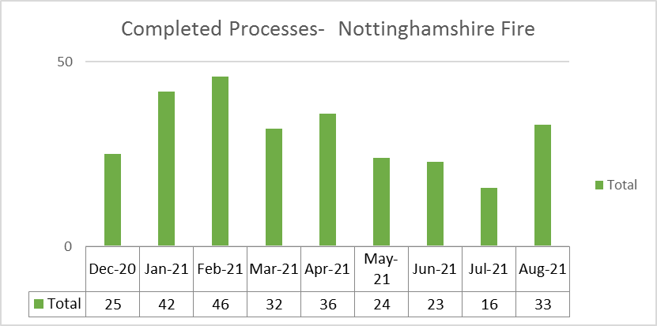

* 1. Work in Progress

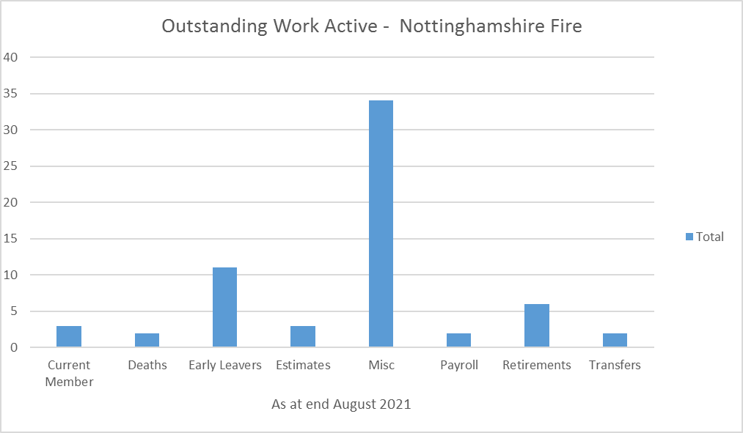

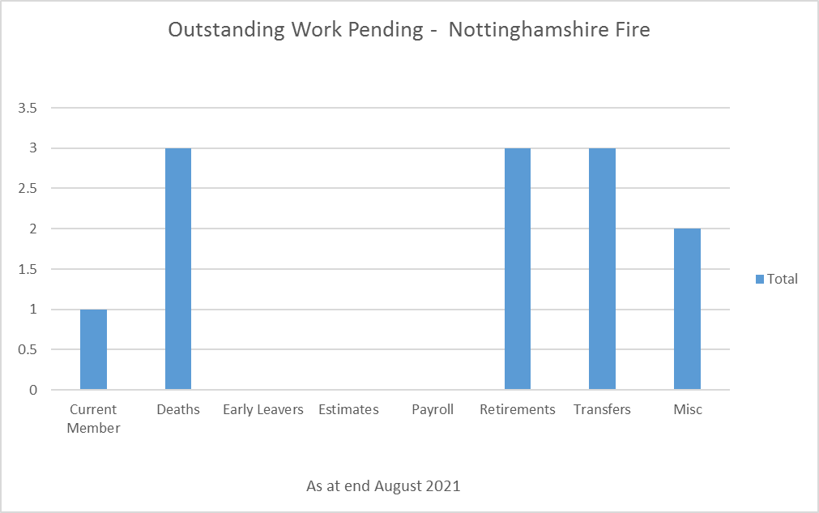

1. **Member Web Registrations**

The number of members signed up to member web are:

|  |  |
| --- | --- |
| Status | Number |
| Active | 245 |
| Pensioner | 349 |
| Pensioner Ex Spouse | 0 |
| Beneficiary Pensioner | 0 |
| Deferred Ex Spouse | 0 |
| Deferred | 85 |

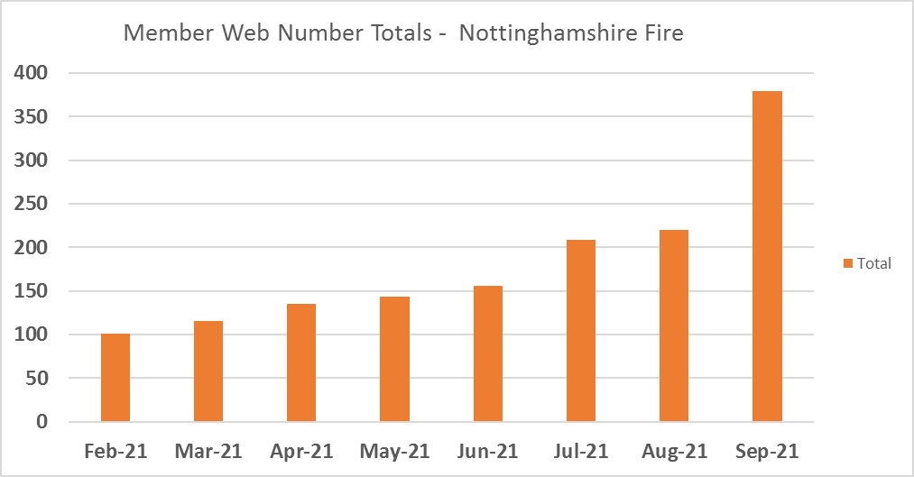

1. **Calendar of Events**

|  |  |  |  |
| --- | --- | --- | --- |
| January | February | March | April |
| Life Certificates  HMRC Event Reporting  Payment of Unauthorised Lump Sum and Scheme Sanction Charge to HMRC | Life Certificates  Review of DWP benefits for Injury cases  GAD Data Collection Spreadsheet? | Life Certificates | Apply Pensions Increase  Apply Care Revaluation  Issue P60’s  Life Certificates  Pensioner Newsletter |
| May | June | July | August |
| Roll out of Monthly Postings  Life Certificates | Active Newsletter  Life Certificates  Issue Deferred Annual Benefits Statements | Life Certificates  Issue Deferred Annual Benefits Statements  Issue active Annual Benefits Statements | Issue active Annual Benefits Statements  Life Certificates |
| September | October | November | December |
| Pension Estimates Assumption Exercise  Life Certificates  Pension Savings Statement | Life Certificates  Participate in NFI  tPR Scheme Returns | tPR Annual Survey  Life Certificates | IAS19 Data capture exercise for Actuaries  Life Certificates |

1. **Membership Numbers**

|  |  |  |  |  |  |  |
| --- | --- | --- | --- | --- | --- | --- |
| **Scheme Name** | **Active Members** | **Deferred Members** | **Pensioners** | **Beneficiaries** | **Preserved Refund** | **Leavers Options Pending** |
| Nottinghamshire (1992 Scheme) | 31 | 45 | 715 | 114 | 1 | 0 |
| Nottinghamshire (2006 Scheme) | 4 | 159 | 27 | 9 | 6 | 0 |
| Nottinghamshire (2015 Scheme) | 584 | 155 | 11 | 0 | 0 | 0 |

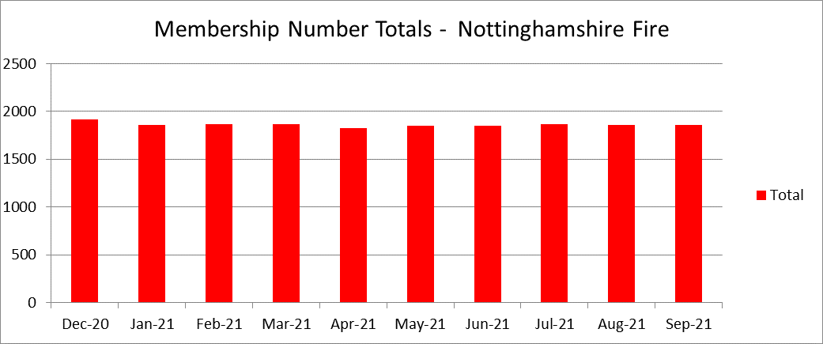

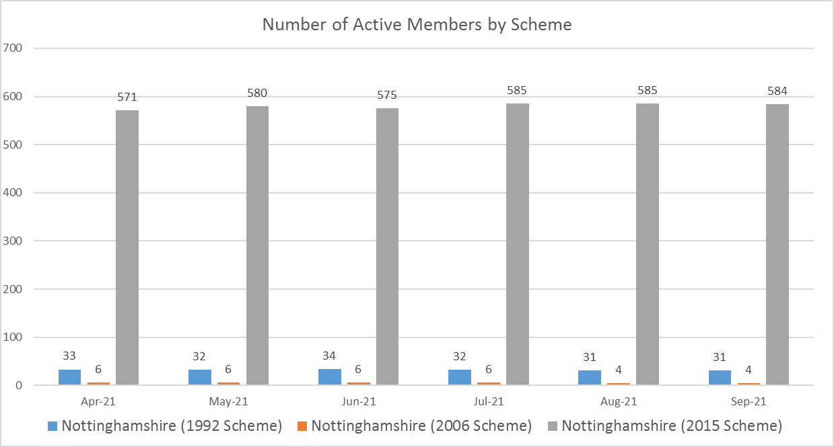

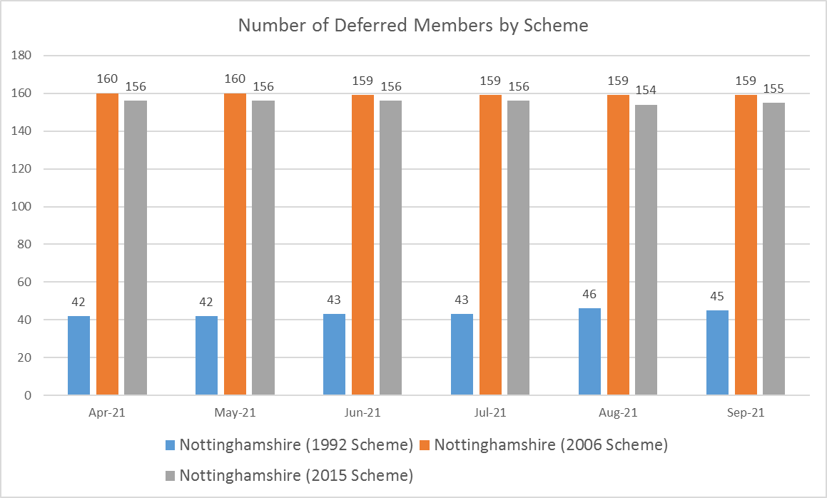

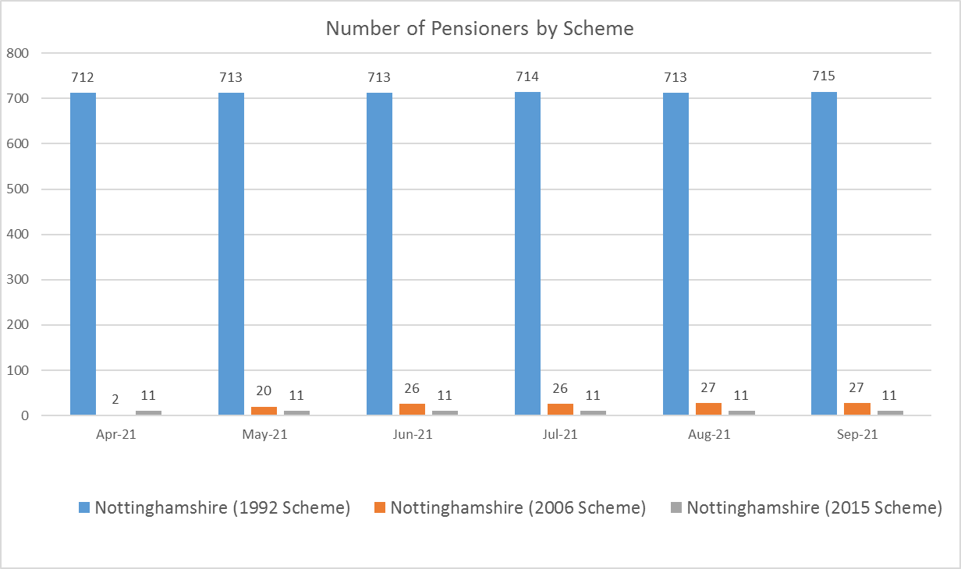

1. **Five Year Audit Plan 2019 – 2024**

|  |  |  |  |  |  |  |  |  |  |  |
| --- | --- | --- | --- | --- | --- | --- | --- | --- | --- | --- |
| **West Yorkshire Pension Fund Five Year Audit Plan 2019 - 2024** | **Frequency** | **Last Audit** | **Recommendations** | **Days** | **19/20** | **20/21** | **21/22** | **22/23** | **23/24** | **Total** |
|  |  |  |  |  |  |  |  |  |  |  |
| Annual Accounts Verification | Annual | Jul 18 | 1 | 10 | **🗸** | **🗸** | **🗸** | **🗸** | **🗸** |  |
|  |  |  |  |  |  |  |  |  |  |  |
| **Audits Per Year** |  |  |  |  | **1** | **1** | **1** | **1** | **1** | **5** |
| **Benefits** |  |  |  |  |  |  |  |  |  |  |
| Local Government Scheme Contributions | 2 Yearly | Nov 18 | 0 | 20 |  |  | 🗸 |  | 🗸 |  |
| New Pensions and Lump Sums - WYPF |  |  |  |  |  |  |  |  |  |  |
| - Normal and Early Retirements | 5 Yearly | Mar 15 | 0 | 25 | **🗸** |  |  |  |  |  |
| - Death in Service, Post Retirement Widow and Dependent Benefits | 5 Yearly | Mar 17 | 0 | 20 |  |  | 🗸 |  |  |  |
| - Ill Health Pensions | 5 Yearly | Oct 13 | 2 | 20 |  |  |  |  | 🗸 |  |
| - Flexible Retirements | 5 Yearly | Apr 16 | 1 | 20 |  | 🗸 |  |  |  |  |
| - Deferred Pensions | 5 Yearly | Mar 18 | 0 | 20 |  |  |  | 🗸 |  |  |
|  |  |  |  |  |  |  |  |  |  |  |
| Transfers Out | 3 Yearly | Nov 17 | 0 | 20 |  | 🗸 |  |  |  |  |
| Transfers In | 3 Yearly | Sep 16 | 2 | 20 | **🗸** |  | **🗸** |  |  |  |
| Reimbursement of Agency Payments | 5 Yearly | Mar 18 | 2 | 15 |  |  |  | 🗸 |  |  |
| Life Certificates | 5 Yearly | Oct 15 | 0 | 15 |  | 🗸 |  |  |  |  |
| AVC Arrangements | 5 Yearly | Sep 17 | 0 | 15 |  |  |  | 🗸 |  |  |
| Admission of New Bodies | 5 Yearly | Jan 15 | 0 | 20 | **🗸** |  |  |  |  |  |
| Pensioners Payroll | 2.5 years | Mar 16 | 3 | 20 |  | 🗸 |  |  | 🗸 |  |
| Purchase of Additional Pension | 5 Yearly | Mar 17 | 1 | 15 |  |  | 🗸 |  |  |  |
| Annual Benefits Statements | 2.5 years | Oct 16 | 0 | 20 | **🗸** |  |  | **🗸** |  |  |
|  |  |  |  |  |  |  |  |  |  |  |
| New Pensions and Lump Sums - Fire Service | 3 Yearly | Jul 18 | 1 | 15 |  | 🗸 |  |  | 🗸 |  |
|  |  |  |  |  |  |  |  |  |  |  |
| **Audits Per Year** |  |  |  |  | **4** | **5** | **4** | **4** | **4** | **21** |

**9.0 Overriding Disclosure Time Limits**

|  |  |  |
| --- | --- | --- |
| **Disclosure Requirement** | **Time Limit** | **Number of breaches in month** |
| Material alterations to basic scheme information | Within 3 months of the change taking effect | 0 |
| Transfer Credits (quote) | Within 2 months | 0 |
| Annual Benefit Statements | By 31 August each year | 0 |
| Annual Benefit Statement (upon request) | Within 2 months of request, if not already provided within previous 12 months | 0 |
| Deferred Benefit Statements | By 31 August each year | 0 |
| Deferred Benefit Statement (upon request) | Within 2 months of request, if not already provided within previous 12 months | 0 |
| Pension Savings Statements | By 6 October each year | 0 |
| Cash Equivalent Transfer Value Out | Within 3 months of request | 0 |
| Accessing Benefits before Normal Pension Age | 2 month of benefits becoming payable | 0 |
| Accessing Benefits on or after Normal Pension Age | 1 month of benefits becoming payable | 0 |
| Notification of Deferred Benefit entitlement | 2 months of being notified of leaver | 0 |

**Divorce Time limits**

|  |  |  |
| --- | --- | --- |
| **Type of request** | **Time limit** | **Number of breaches in month** |
| Request for divorce information only. | 3 months from receipt of the request. | 0 |
| Request for divorce information where you are notified that the information is required in connection with divorce proceedings that have already commenced. | 6 weeks from receipt of the request. | 0 |
| Request for divorce information where a Court Order imposes a deadline. | Within the deadline specified by the Court. | 0 |
| Request for divorce information where you are notified that a Pension Sharing Order may be issued. | Within 21 days of receiving notification that a Pension Sharing Order may be issued or a date outside 21 days as specified by the Court. | 0 |
| Where the request is for information which does not include a Cash Equivalent Transfer Value. | 1 month from receipt of the request. | 0 |
| Pension Sharing Order received but some information* and/or charges are still outstanding. | A letter to both parties needs to be sent out within 21 days of receiving the Order to explain the Order cannot be implemented and request the missing information and/or charges. | 0 |
| Pension Sharing Order received including all relevant information* and charges. | A letter** must be sent to both parties within 21 days of the start of the implementation period notifying them of the deadline. | 0 |
| Pension Sharing Order Received including all relevant information and charges. | 4 months to implement the Order of the date of receipt of the final information which allows calculation | 0 |
| PSO has been implemented. | A letter* must be sent to both parties within 21 days of implementing the PSO to notify both parties their entitlement. | 0 |