On-Call Firefighter Selection Process
Application Form
All candidates will be required to complete and submit an online application form which will include your personal details and a number of questions to assess your eligibility to apply, as well as completing an availability form.
Stage 1: Written Tests:
- A multiply choice written and numeracy test.
- A Dictation and memory recall tests.
Stage 2: Job Related Tests
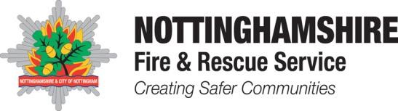
The following job related tests will be undertaken:
Test | Description
Bleep Test | To assess aerobic fitness candidates will be expected to achieve Level  8 Shuttle 7 (42.3 VO2 max)  If you are unsuccessful in achieving the required level at this point, you will be withdrawn from the process
Ladder Climb | To assess candidate’s confidence at heights and ability to follow instructions
Ladder Lift | To assess upper body strength
Equipment Carry | To test aerobic fitness, stamina, upper and lower body strength
Equipment Assembly | To test manual dexterity
Enclosed Spaces Test | To assess confidence working within confined spaces
Handgrip Test | 25kg in both the dominant and non-dominant hand.
Hose Running | To assess aerobic fitness and co-ordination

To view some of our job-related tests being carried out, please click the YouTube links below:
Introduction. Ladder Climb. Ladder Lift. Equipment Carry. Equipment Assembly. Enclosed Space. Hose Running. Bleep Test.
Stage 3: Interview
Candidates will be invited to a formal interview. Here they will be asked a series of questions around the PQA’s.
Stage 4: Medical.
Candidates will undertake a full medical, substance misuse test, and a face fit test. They will then be invited for a kit fitting.

Stage 5: Pre-employment Checks.

Candidates will be subject to a baseline personnel security standard check which will include 3-year employment history and asylum and immigration check. References will be taken up at this stage.

