

March 2021

Nottinghamshire Fire Authority

Prepared by:

**Yunus Gajra**

Business Development Manager

Tel: 01274 432343

Mobile: 07582105760

Email: Yunus.gajra@wypf.org.uk

West Yorkshire Pension Fund

Aldermanbury House

4 Godwin Street

Bradford

BD1 2ST

www.wypf.org.uk

Follow WYPF on Twitter [www.twitter.com/wypf_lgps](http://www.twitter.com/wypf_lgps)

Follow WYPF on Facebook [www.facebook.com/westyorkshirepensionfund](http://www.facebook.com/westyorkshirepensionfund)







Contents

1 Regulations/Fire Scheme Update 4

2 Member Issues 9

3 Administration Issues 9

4 Key performance Indicators 10

4 Work in progress 11

5 Member web registrations 12

6 Calendar of Events 13

7 Membership Numbers 14

8 Five Year Audit Plan 18

9 Overriding Disclosure Time Limits 19

**1.0** **1.0 Regulations/Fire Scheme Update**

1.1 SAB Bulletin

Please take a few minutes to read the Firefighters’ Pension (England) Scheme Advisory Board Bulletin (Link to Bulletin 42 below) and take any action required.

[Bulletin 42](http://fpsboard.org/)

Items to highlight:

**FPS Age discrimination remedy consultation response published**

On 4 February HM Treasury (HMT) published its consultation response on changes  
to the transitional arrangements to the 2015 public service pension schemes.  
The response confirms that discrimination will be addressed in two parts.  
To remove future discrimination from the schemes and ensure equal treatment, all  
remaining protected members who are not currently members of FPS 2015 will  
transfer into this scheme on 1 April 2022. This means that all future service for all  
members will build up in the reformed CARE scheme. Final salary benefits already  
built up are fully protected.  
   
For benefits built up during the period of discrimination, 1 April 2015 to 31 March  
2022, unprotected and taper members will be credited with final salary build-up in  
their original scheme. At retirement, all members will be able to keep their legacy  
final salary benefits or choose to receive the CARE benefits that they would have  
built up in the same period.

While we expect that transferring remaining members into FPS 2015 at 1 April 2022  
will be relatively straightforward, the conversion of CARE benefits into final salary will  
involve complex administrative processes with adjustments of pay, contributions, tax  
relief, and pensions tax liabilities.

The consultation response addresses some of these issues, however, further policy  
decisions are needed in some areas. The Home Office will consult separately on  
changes needed to the Firefighters’ Pension Scheme regulations to enact the  
remedy.

We understand that members will have many questions about what these changes  
mean. At present, employers and administrators can only provide the general  
information that can be found in the consultation response. Until the necessary  
changes are made to the pension administration software systems, it will not be  
possible to provide estimates of benefits for members. This is likely to take some  
time.

Members do not need to take any action, as remedy will automatically be applied if  
they are eligible. The Home Office has published a list of frequently asked questions  
with information about scope and the decisions that the government have made.  
We are working closely and at pace across the whole of the FPS sector and with  
government departments to support FRAs through the remedy implementation  
process.

**Valuation**

At the same time as publishing the response setting out the government’s approach  
to removing discrimination, HMT also announced the position on both the paused  
2016 cost cap valuation and the 2020 valuation, in written statement HCWS757.

**2016 valuation**

The pause on the 2016 cost cap valuation will now be lifted, and the Government  
Actuary’s Department (GAD) will now proceed with finalising the valuations based on  
the DCU approach to removing discrimination.  
   
The cost cap for the FPS was set as 16.8 per cent1 as at 1 April 2015. The  
provisional result of the 2016 valuation before the pause was effected was a cost  
cap cost of 11.6 per cent2, which was 5.2 per cent lower than the cost cap floor set in April 2015.

The current process sets out that any breach to the floor of the cost cap would see  
improvements to scheme benefits to bring the cost cap back within range and,  
conversely, any ceiling breaches would see reductions to scheme benefits. Floor  
breaches refer to a change in value by more than 2 per cent below the established  
cost cap, i.e. less than 14.8 per cent, and a ceiling breach is a change in value by  
more than 2 per cent above this figure, i.e. more than 18.8 per cent.

Employers are continuing to pay increased employer contributions based on  
improving scheme benefits because of the floor breach in the paused 2016 cost cap  
valuation.

The government confirmed that early estimates of the cost cap taking into account  
the increased value of public service schemes to members as a result of the  
McCloud remedy mean that on review some schemes would now breach the ceiling.  
For the FPS this would mean the cost cap cost once calculated would have to be  
above 18.8 per cent.

If normal statutory procedure were followed, any ceiling breaches would lead to a  
reduction in member benefits to bring costs back to target. However, the  
government have announced that it would be inappropriate to reduce member  
benefits at this time and the effect of any ceiling breaches on the 2016 valuation  
would be waived.

**2020 valuation**

In July 2020 the government announced a review to the mechanism to control the  
cost of public service pensions for future valuations. While this review will not affect  
the process of the 2016 cost cap valuation which will continue on the current  
mechanism, the 2020 valuation will be subject to any recommendations as a result of  
this review.  
The Government announced in written statement HCWS757 that due to interactions  
with wider pension policies, in particular the implementation of the McCloud remedy  
reforms, completion of the 2016 valuation process and the review of the cost control  
mechanism, any changes to employer contribution rates resulting from the 2020  
valuations will be delayed from April 2023 to April 2024.

That has the effect that employer contributions will remain at the same rate as set in  
the 2016 valuation until 2024. Further updates on any changes to that position will  
be made when information becomes available.

**Transitional protections pensions claims: Schedule 22 appeal judgment**

On 12 February, the Employment Appeal Tribunal (EAT) gave its judgment on the  
FRAs’ appeal based on Schedule 22 of the Equality Act 2010. This appeal was  
based on the argument that the FRAs did not make the legislation which was found  
by the Court of Appeal to be discriminatory on grounds of age but were bound to  
follow it because it was the law. The EAT held that the FRAs cannot rely on the  
Schedule 22 defence.

Further information has been provided to the person nominated by each FRA to  
receive communications in respect of this, and related, legal cases.  
The Steering Committee and legal representatives are considering whether it is  
appropriate to appeal the judgment.

**Immediate Detriment**

Following the decision of the EAT on the FRAs’ schedule 22 appeal detailed above  
and its effect on Section 61 of the Equality Act 2010, FRAs will now want to consider  
their decision in relation to payments under the immediate detriment guidance, which  
was issued by the Home Office at the request of the Fire Brigades Union on 21  
August 2020.

FRAs now need to determine whether they have the necessary information available  
to them to make decisions and understand the risk to their organisation. To do this  
they may want to consider:

1. Is the six-page note provided by the Home Office and in-house scheme  
knowledge sufficient to enable accurate calculations for members?

The note from the Home Office is labelled as informal guidance only. There  
has been no update from HMT or the Home Office on this note since it was  
published in August 2020, albeit a more cautionary note was included under  
question 10 of the Home Office FAQs that the legislation that allows schemes  
to do this is limited in effect (we believe that is a reference to Section 61 of the  
Equality Act), which does not allow for all consequential matters to be dealt  
with satisfactorily in all cases. For example, in cases where there are  
interactions with the tax system, perhaps where members have incurred or  
will incur tax charges or where contributions differ between the schemes.

The LGA published an immediate detriment information note for FRAs in  
October which gave further clarification of the technical issues yet to be  
commented on by the Home Office or HMT and the issues that would need to  
be decided by FRAs in their decision making on making any immediate  
detriment payments.

2. What does the local cohort of membership look like with regards to members  
whose calculation of benefits would be subject to policy decisions yet to be  
made, such as CETVs received after 1 April 2015, added pension payments,  
or pensions tax?  
   
The Scheme Advisory Board (SAB) requested data from FRAs on these  
cohorts but only received 33 of 45 replies.

3. What risk is there to the member on accepting payments without key policy  
decisions in place, and how will the member be told of this risk?

In considering this risk FRAs and members may wish to consider that final  
policy decisions have not yet been made on issues such as, how to claim tax  
relief on pension contributions owed, how to apply interest to contributions  
due, how pension tax might be calculated and paid, and what legislation is in  
place to deal with these issues before the pension scheme regulations are  
changed bearing in mind the note of caution in question 10 of the FAQs.

4. What governance might FRAs put in place to assure themselves that:

1. The correct benefits will be paid to members
2. Members have been satisfactorily made aware of expectations such as  
   future payments owed due to interest being applied to contributions  
   arrears.
3. Necessary processes will be in place to calculate and record the  
   payments due bearing in mind that no automated processes or  
   systems are available for the calculations until the significant software  
   development needed has been completed.

5. How might they record their decision making so it is clear and transparent?

Having considered the above points, FRAs will wish to ensure they document  
their decision making for clarity and transparency. An assessment matrix was  
included with the October note to help FRAs identify whether they have all the  
information necessary to make a payment.

**Draft remedy data collection guidance**

In order to credit members with their original legacy scheme membership for the  
remedy period, administrators will need additional data from FRAs to rebuild the final  
salary record. For example, an unprotected member who transitioned to FPS 2015  
from FPS 1992 on 1 April 2015 and remains in employment will need a final salary  
record creating for the full seven years from 1 April 2015 to 31 March 2022.

To assist administrators and FRAs with the process of collecting data and ensure  
consistency where possible, we intend to provide a template of data items that will  
be required. We are currently working with the software companies to agree the  
required data fields and formats. In the meantime, we have written a supporting  
document in conjunction with the Fire Communications Working Group (FCWG) to  
allow parties to identify where additional data will be required and what processes  
might need to be put in place to collate it.

FRAs should now work with their administrators to identify all eligible members and  
consider any processes or additional resources that need to be put in place to  
identify the data required, in advance of the standard template being provided.

**FPS contribution rates 2021-22**

Banded contribution rates were introduced to the Firefighters’ Pension Scheme 1992  
and the Firefighters’ Pension Scheme (England) 2006 by Statutory Instruments  
2012/953 and 2012/954 respectively.

These rates have subsequently been amended each year by an amendment order to  
the schemes. The most recent amendments4 , which came into force on 1 April  
2015, listed the rates applicable from 2015-2016 to 2018-2019, including contribution  
rates for Special Members of the Firefighters’ Pension Scheme (England) 2006.

The Firefighters’ Pension Scheme 2015 was introduced on 1 April 2015 by SI  
2014/2848. Regulation 110 set out details rates applicable from 2015-2016 to 2018-  
2019.

For 2019-2020, FRAs were instructed that the 2018-2019 rates would continue to  
apply, due to the pause of the cost-cap mechanism. These rates will continue to  
apply for 2021-2022. The contribution rate factsheet reminds FRAs of the  
contribution rates set out in the above Regulations and Orders which will apply from  
1 April 2021.

**2.0 Member Issues**

None

**3.0 Administration Update**

3.1 Remote working

WYPF staff continue to provide a full service both to FA’s and Member’s during the current Covid-19 crisis. All staff are enabled to work from home with occasional visits to the office as and when necessary.

3.2 2020 valuation - Data collection spreadsheet

Data extracts required by the Government Actuaries Department for the 2020 Valuation exercise were submitted by the required deadline.

* 1. Pensions Increase

Public service pensions will be increased in line with the annual increase in the Consumer Prices Index up to September 2020. The increase from 12 April 2021 is 0.5%.

* 1. HMRC Annual Event Reporting

The information was submitted to HMRC were submitted before the end of January deadline. The Unauthorised lump sum tax charge and Scheme Sanction Charge payments were made to HMRC on 23 January 2021 and a copy of the information was supplied to the FA.

3.5 Keep in Touch

To help keep you up to date with the latest scheme and administration news make sure you follow our client blog, Hot Topics at:

[www.wypfpensionmattersfire.wordpress.com/](https://wypfpensionmattersfire.wordpress.com/)

To follow the blog, click follow and put in your work email address. You’ll then be notified every time we add something to it.

1. **Key Performance Indicators**

4.1 Completed processes

|  |  |  |  |  |  |  |
| --- | --- | --- | --- | --- | --- | --- |
| Nottinghamshire FA (1 to 28 February 2021) | | | | | |  |
| **Work Type** | **Total Cases** | **Target days for each case** | **Target met cases** | **Minimum Target Met** | **Target met percent** | **Average time taken** |
| Age 55 Increase to Pension | 6 | 20 | 6 | 85 | 100 | 11.33 |
| Change of Address | 5 | 20 | 5 | 85 | 100 | 3 |
| Death in Retirement | 4 | 5 | 4 | 85 | 100 | 2.25 |
| Deferred Benefits Set Up on Leaving | 5 | 10 | 3 | 85 | 60 | 13.6 |
| Initial letter Death in Retirement | 4 | 5 | 4 | 85 | 100 | 3.25 |
| Pension Estimate | 5 | 10 | 4 | 85 | 80 | 8.2 |
| Pension Saving Statement | 1 | 20 | 1 | 100 | 100 | 1 |
| Pension Set Up -Payment of Lump Sum | 1 | 3 | 1 | 85 | 100 | 1 |
| Retirement Actual | 1 | 10 | 1 | 85 | 100 | 1 |
| Set Up New Spouse Pension SY Fire | 3 | 5 | 3 | 85 | 100 | 1 |
| Spouse Potential | 1 | 10 | 0 | 85 | 0 | 22 |
| Update Member Details | 10 | 20 | 10 | 100 | 100 | 1 |

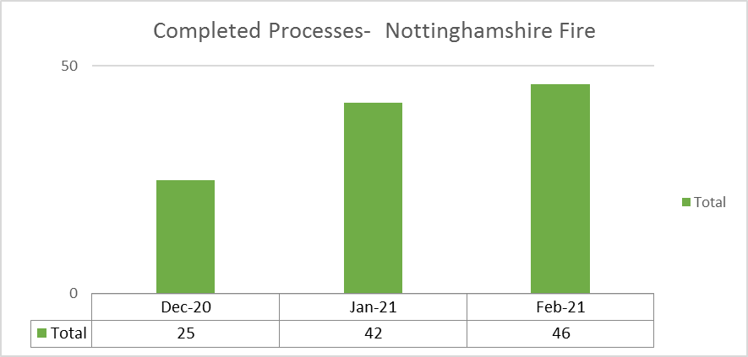

* 1. Work in Progress

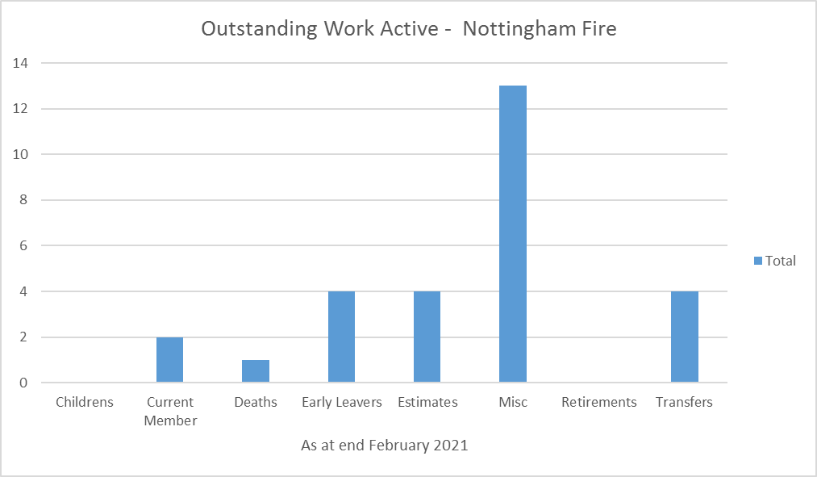

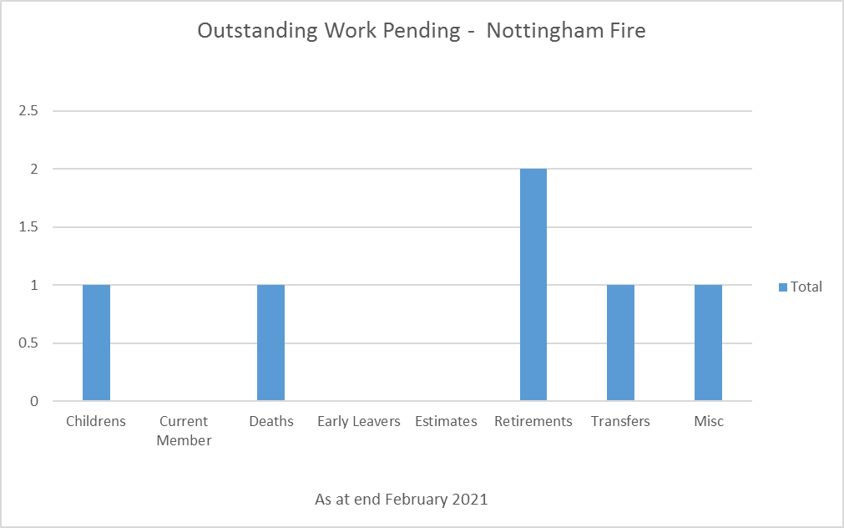

1. **Member Web Registrations**

The number of members signed up to member web are:

|  |  |
| --- | --- |
| Status | Number |
| Active | 71 |
| Pensioner | 22 |
| Pensioner Ex Spouse | 0 |
| Beneficiary Pensioner | 0 |
| Deferred Ex Spouse | 0 |
| Deferred | 23 |

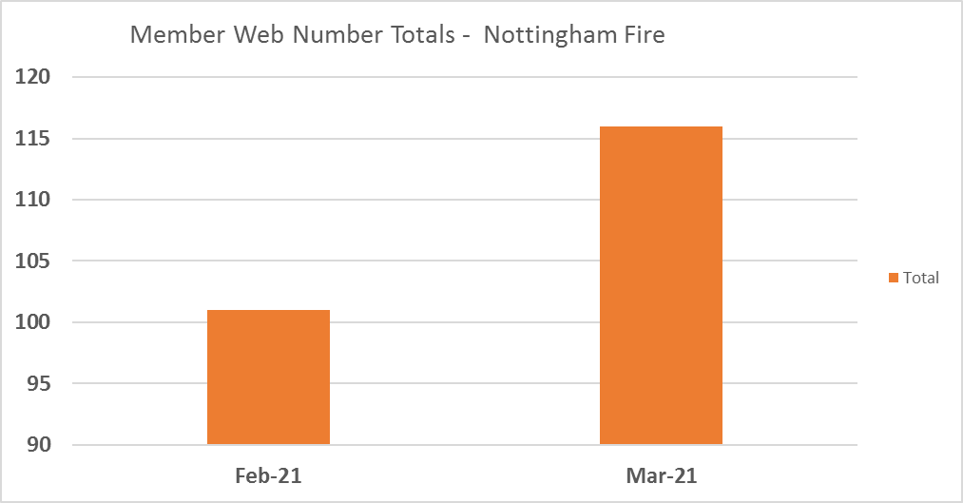

1. **Calendar of Events**

|  |  |  |  |
| --- | --- | --- | --- |
| January | February | March | April |
| Life Certificates  HMRC Event Reporting  Payment of Unauthorised Lump Sum and Scheme Sanction Charge to HMRC | Life Certificates  Review of DWP benefits for Injury cases  GAD Data Collection Spreadsheet? | Life Certificates | Apply Pensions Increase  Apply Care Revaluation  Issue P60’s  Life Certificates  Pensioner Newsletter |
| May | June | July | August |
| Roll out of Monthly Postings  Life Certificates | Active Newsletter  Life Certificates  Issue Deferred Annual Benefits Statements | Life Certificates  Issue Deferred Annual Benefits Statements  Issue active Annual Benefits Statements | Issue active Annual Benefits Statements  Life Certificates |
| September | October | November | December |
| Pension Estimates Assumption Exercise  Life Certificates  Pension Savings Statement | Life Certificates  Participate in NFI  tPR Scheme Returns | tPR Annual Survey  Life Certificates | IAS19 Data capture exercise for Actuaries  Life Certificates |

1. **Membership Numbers**



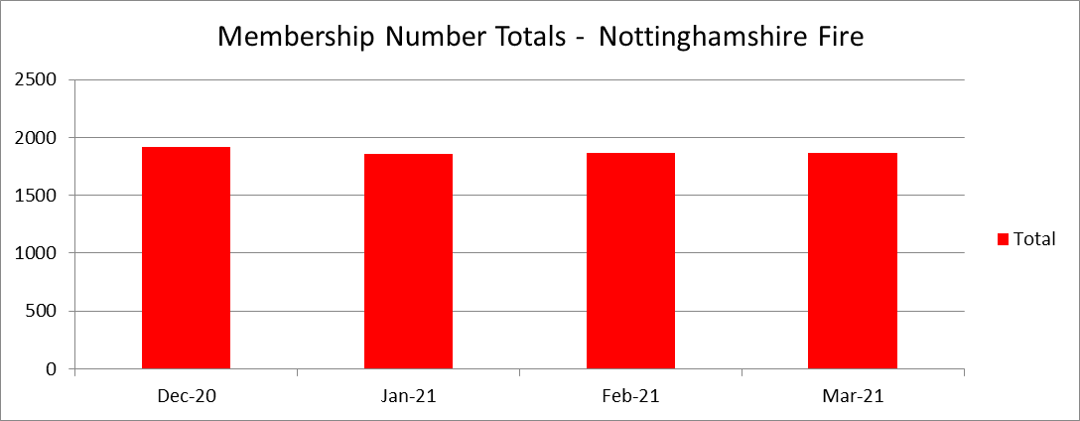

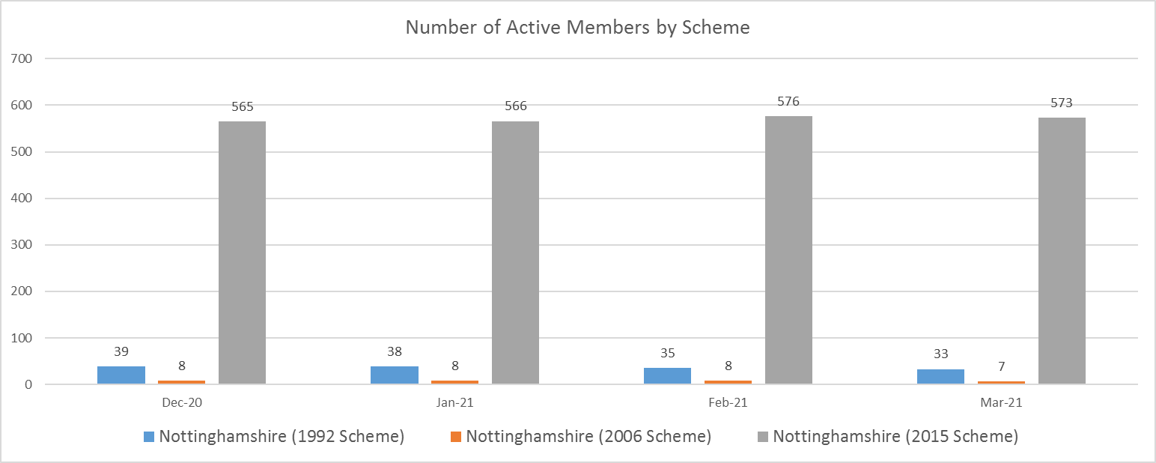

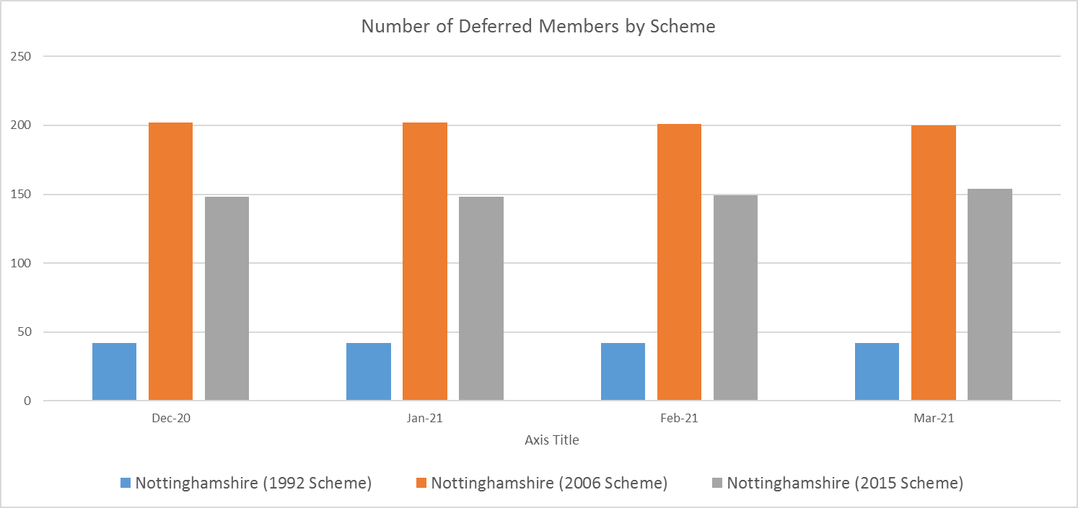

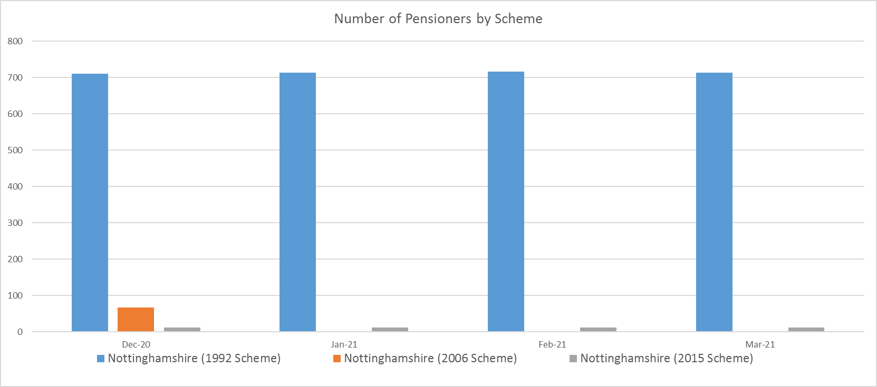

1. **Five Year Audit Plan 2019 – 2024**

|  |  |  |  |  |  |  |  |  |  |  |
| --- | --- | --- | --- | --- | --- | --- | --- | --- | --- | --- |
| **West Yorkshire Pension Fund Five Year Audit Plan 2019 - 2024** | **Frequency** | **Last Audit** | **Recommendations** | **Days** | **19/20** | **20/21** | **21/22** | **22/23** | **23/24** | **Total** |
|  |  |  |  |  |  |  |  |  |  |  |
| Annual Accounts Verification | Annual | Jul 18 | 1 | 10 | **🗸** | **🗸** | **🗸** | **🗸** | **🗸** |  |
|  |  |  |  |  |  |  |  |  |  |  |
| **Audits Per Year** |  |  |  |  | **1** | **1** | **1** | **1** | **1** | **5** |
| **Benefits** |  |  |  |  |  |  |  |  |  |  |
| Local Government Scheme Contributions | 2 Yearly | Nov 18 | 0 | 20 |  |  | 🗸 |  | 🗸 |  |
| New Pensions and Lump Sums - WYPF |  |  |  |  |  |  |  |  |  |  |
| - Normal and Early Retirements | 5 Yearly | Mar 15 | 0 | 25 | **🗸** |  |  |  |  |  |
| - Death in Service, Post Retirement Widow and Dependent Benefits | 5 Yearly | Mar 17 | 0 | 20 |  |  | 🗸 |  |  |  |
| - Ill Health Pensions | 5 Yearly | Oct 13 | 2 | 20 |  |  |  |  | 🗸 |  |
| - Flexible Retirements | 5 Yearly | Apr 16 | 1 | 20 |  | 🗸 |  |  |  |  |
| - Deferred Pensions | 5 Yearly | Mar 18 | 0 | 20 |  |  |  | 🗸 |  |  |
|  |  |  |  |  |  |  |  |  |  |  |
| Transfers Out | 3 Yearly | Nov 17 | 0 | 20 |  | 🗸 |  |  |  |  |
| Transfers In | 3 Yearly | Sep 16 | 2 | 20 | **🗸** |  | **🗸** |  |  |  |
| Reimbursement of Agency Payments | 5 Yearly | Mar 18 | 2 | 15 |  |  |  | 🗸 |  |  |
| Life Certificates | 5 Yearly | Oct 15 | 0 | 15 |  | 🗸 |  |  |  |  |
| AVC Arrangements | 5 Yearly | Sep 17 | 0 | 15 |  |  |  | 🗸 |  |  |
| Admission of New Bodies | 5 Yearly | Jan 15 | 0 | 20 | **🗸** |  |  |  |  |  |
| Pensioners Payroll | 2.5 years | Mar 16 | 3 | 20 |  | 🗸 |  |  | 🗸 |  |
| Purchase of Additional Pension | 5 Yearly | Mar 17 | 1 | 15 |  |  | 🗸 |  |  |  |
| Annual Benefits Statements | 2.5 years | Oct 16 | 0 | 20 | **🗸** |  |  | **🗸** |  |  |
|  |  |  |  |  |  |  |  |  |  |  |
| New Pensions and Lump Sums - Fire Service | 3 Yearly | Jul 18 | 1 | 15 |  | 🗸 |  |  | 🗸 |  |
|  |  |  |  |  |  |  |  |  |  |  |
| **Audits Per Year** |  |  |  |  | **4** | **5** | **4** | **4** | **4** | **21** |

**9.0 Overriding Disclosure Time Limits**

|  |  |  |
| --- | --- | --- |
| **Disclosure Requirement** | **Time Limit** | **Number of breaches in month** |
| Material alterations to basic scheme information | Within 3 months of the change taking effect | 0 |
| Transfer Credits (quote) | Within 2 months | 0 |
| Annual Benefit Statements | By 31 August each year | 0 |
| Annual Benefit Statement (upon request) | Within 2 months of request, if not already provided within previous 12 months | 0 |
| Deferred Benefit Statements | By 31 August each year | 0 |
| Deferred Benefit Statement (upon request) | Within 2 months of request, if not already provided within previous 12 months | 0 |
| Pension Savings Statements | By 6 October each year | 0 |
| Cash Equivalent Transfer Value Out Out | Within 3 months of request | 0 |
| Accessing Benefits before Normal Pension Age | 2 month of benefits becoming payable | 0 |
| Accessing Benefits on or after Normal Pension Age | 1 month of benefits becoming payable | 0 |
| Notification of Deferred Benefit entitlement | 2 months of being notified of leaver | 0 |

**Divorce Time limits**

|  |  |  |
| --- | --- | --- |
| **Type of request** | **Time limit** | **Number of breaches in month** |
| Request for divorce information only. | 3 months from receipt of the request. | 0 |
| Request for divorce information where you are notified that the information is required in connection with divorce proceedings that have already commenced. | 6 weeks from receipt of the request. | 0 |
| Request for divorce information where a Court Order imposes a deadline. | Within the deadline specified by the Court. | 0 |
| Request for divorce information where you are notified that a Pension Sharing Order may be issued. | Within 21 days of receiving notification that a Pension Sharing Order may be issued or a date outside 21 days as specified by the Court. | 0 |
| Where the request is for information which does not include a Cash Equivalent Transfer Value. | 1 month from receipt of the request. | 0 |
| Pension Sharing Order received but some information* and/or charges are still outstanding. | A letter to both parties needs to be sent out within 21 days of receiving the Order to explain the Order cannot be implemented and request the missing information and/or charges. | 0 |
| Pension Sharing Order received including all relevant information* and charges. | A letter** must be sent to both parties within 21 days of the start of the implementation period notifying them of the deadline. | 0 |
| Pension Sharing Order Received including all relevant information and charges. | 4 months to implement the Order of the date of receipt of the final information which allows calculation | 0 |
| PSO has been implemented. | A letter* must be sent to both parties within 21 days of implementing the PSO to notify both parties their entitlement. | 0 |