

NOTTINGHAMSHIRE FIRE AUTHORITY
PENSION BOARD

16th March 2020

REPORT FROM LEICESTERSHIRE COUNTY COUNCIL – PENSION ADMINISTRATOR

PENSION FUND ADMINISTRATION REPORT – QUARTER 1ST OCTOBER TO 31ST DECEMBER 2019

Purpose of the Report

To inform the Fire Pension Board of fire-fighter pension administration in the quarter.

This is designed to assist the Fire Pension Board. It is also considered best practise to provide a report of this type.

Areas

Annual Benefit Statements / Year-end / Taxation Saving Statements

Leicestershire County Council issued the annual benefit statements by 31st August 2019 and the Pension Saving statements by 6th October 2019. There were 7 Pension Saving statements sent for 2018/19 for Nottinghamshire Fire and Rescue Service. All members have replied where necessary for them to do so.

Valuation 2020

The Government Actuary’s Department (GAD) has issued the draft 2020 valuation data specifications for FPS England. This has been circulated by email to software suppliers and administrators. The data specifications are mostly the same as they were for the 2016 valuation, with the one major addition being the inclusion of extra data requirements for salary and contribution information between 2015 and 2020 following the McCloud judgement. GAD will follow up in the near future with the required data collection spreadsheet and instructions.

Regulation Changes

None since last report

Update on Sargeant case (transitional protections remedy)

On 18th December 2019, the Employment Tribunal made an interim order on the firefighters’ transitional protections claims. An employer’s circular from the National Employers has been sent to FRAs informing them of the detail.
That circular is available at the following link:

https://www.local.gov.uk/sites/default/files/documents/EMP%208%2019%20-%20FPS%202015%20CMPH%20-%20Final.pdf

The Home Office have also provided a factsheet that can be issued to members available here:

http://fpsregs.org/images/Bulletins/Bulletin-27-December-2019/Bulletin-27-Appendix-1.pdf

Additionally, the LGA have issued suggested text for FRAs to use in order to respond to member queries as below:

“We are aware of the interim declaration made by the Employment Tribunal that claimants
represented in the Sargeant legal case are entitled to be treated as if they remained in the
Firefighters Pension Scheme 1992 (FPS 1992). In order to comply with the Tribunal’s order
FRAs will need further direction from Government on the practical steps to enable
implementation and we await that direction, albeit the Home Office have since issued a
factsheet.
In the meantime, to enable us to prioritise urgent cases, if you believe you are a claimant and
you have an immediate retirement event; i.e. you are going through or have gone through an
ill-health retirement or you wish to retire from the scheme with immediate effect and meet
the eligibility requirements of being over 50 with 25 years’ service (incudes service in the
2015 Scheme) please contact [insert relevant contact details] with confirmation of your
status as a claimant and details of your retirement claim.
The order does not specify treatment of non-claimants at this time, however Government
have confirmed their intent that non-claimants in the same legal and factual position as
claimants intends to extend the same treatment to all members of the public service pension
schemes, including the Firefighters’ scheme, (whether claimants or not) who are in the same
legal and factual position as the claimants. If you are a non-claimant with a similar
immediate retirement event to claimants, please contact us. “

As a result of the need for further guidance, the Pension Section is currently unable to re-calculate any pension benefits already paid or to base benefits on the 1992 scheme where members are due to or have already transitioned into the 2015 scheme. Once full guidance is released, FRAs and pension administrators will be in a better position to proceed.

Risk and Breaches – (material or not)

None

Common and Scheme-specific Data

Nottinghamshire Fire Authority requested to use the Aquila Heywood report to obtain common data and scheme-specific data for this year in order to complete TPR’s annual return. As no specific fields have been agreed between the LGA and the software provider, the fields reported on are wide ranging, including fields that have not been tested before.
The scores are as follows:

Common Data score: 93.8%
Scheme-specific Data score: 53.7%

The results from the scheme specific report show that there are three main areas which hold noticeably lower scores. These are NI Contributions/Earnings history, Contributions and BCE7 where a death case has occurred.

NI Contributions/Earnings History

The NI Contributions/Earnings History errors are due to different reasons.

Many of these cases look to be:

Pensioner records that do not have an NI earnings screen or

Records where an NI screen is present but with no NI earnings on, however these records may have GMP details in their place.

NI earnings are used to calculate GMPs however where Pensions have received an official GMP notification, the NI earnings have had to be removed in order for the Pension system to accept the GMP on there, otherwise the system thinks that they are duplicating information. Where pensioners do not have an NI earnings screen, this does not mean that they do not have a GMP. This is held on a different screen on the system. Despite this, these records have been categorised as failures.

Contributions

Having looked through a sample of these cases, there appear to be a lot
of cases where, despite all contributions being present on the records, as the system did not input a total contribution amount on the screen in question, the record has shown as a fail. This has been logged with Heywood as the system should be writing back a total amount.

BCE7

These are a small amount of cases where a member has died and the report is expecting there to have been a death grant paid. This has also been logged with Heywood as there are cases where there was no provision in the regulations for a death grant to be paid due to the particular scheme that the member was in, yet these have been shown as fails.
Pensions have a full list of the records which have errored under all the scenarios that have been tested this year. The issues above are national issues which will be affecting other fire authorities as well.

GMP Reconciliation

The position is currently the same as the previous quarter in that the total remaining cases that have been sent to HMRC where we are now awaiting their reply is still 27.

Termination of Administration

The Leicestershire County Council Pension Manager originally terminated the pensions administration function for Nottinghamshire Fire Authority with effect from the 31 March 2020. Following a request from the three fire authorities to extend this date, a revised date of 31st December 2020 has been agreed by all parties. The request to extend the date to 31st December 2020 was due to the fire authorities deciding against their original preferred provider due to costs. A full OJEU Tender is now required.

The termination of the pensions administration is due to the increasing complexity in this area of work as a result of the introduction of the Career Average Revalued Earnings scheme, which is now compounded by the recent Sargeant and McCloud Supreme court judgment on age discrimination.

There are a number of Fire-fighter pension administration providers in the market and the Pension Manager has committed to work constructively with Nottinghamshire Fire Authority to help procure the specialist service required.

As a result of the extended timeline there will be a number of changes in the service which will be provided by Leicestershire County Council. These were discussed at a meeting with all three fire authorities on the 21st January 2020 and were agreed by all parties. The agreed changes are as follows:

- Leicestershire County Council Pensions Section agrees to extending to 31/12/2020 to allow the three FAs time to do a full OJEU tender.
- The Pensions Manager will review the Fire budget from 1/4/2020 to 31/12/2020 and will write to scheme managers separately with the Pensions Section’s revised charges.
- The Fire Team will comprise of two full time staff and additional resource as required (but only if available) – overtime for the team will be available and recharged. One member of the Fire Team still leaves on 31/3/2020, so experience reduces from 3 to 2.
- The Team Manager will need to do more “Fire task work”.
- Certain Fire checking will move to the Pensions Manager.
- The Pensions Manager will negotiate an extension to the Fire Altair system to 31/12/2020. All system charges will be recharged.
- Key Points to note;
  - It’s a valuation year for Fire – meaning extra work on Fire.
  - Leicestershire County Council provide a reduced service from 1/4/2020
    - Increase the timeline for replies – new KPIs below.
    - Cease providing estimates to members – unless within 6 months from retirement (and subsequently cease providing the spreadsheet with the KPIs which shows who has asked for an estimate).
    - Cease issuing deferred ABS to 1992 members as this is not a statutory obligation.
    - Cease projecting forward on the 2020 active ABS (McCloud will change almost all Fire pension benefits, so projecting ahead becomes null and avoid anyway).
    - Provide metric data on a six monthly basis instead of quarterly.
    - Cease providing ad hoc reports when fire authorities ask for people’s NRDs etc.
    - Non-implementation of Member Self Service (MSS) for Fire.
  - There is potentially a large new area of fire work pending - the new modified retained exercise, backdating even further. Leicestershire County Council Pensions Section will not do this and this will be done by the new provider – however this has to be caveated by the potential statutory obligation to complete this by a deadline (as yet unknown). This is a large risk.
  - McCloud – It is unlikely to have the remedy confirmed by 31/12/20 for Fire, so Leicestershire County Council Pensions Section will not do this and it will be done by the new provider – however this has to be caveated by the potential statutory obligation to complete by a deadline (as yet unknown). This is a very large risk.
  - Pensioner payroll implications on an extension to 31/12/2020 has been discussed with Leicestershire County Council Payroll and has been agreed.
  - If the tender outcome provides for the possibility of an administrator using Civica – data migration costs and time (that will be recharged) and risk, are likely to increase.
  - The Pensions Manager and the Team Manager will step down from national Fire responsibilities, FOG Chair and Technical Group representative (Team Manager), CLASS management team lead – Fire and SAB Board effectiveness sub group rep (Pensions Manager), so Leicestershire County Council Pensions Section will not be as closely linked to groups involved in national policy changes and influencing system development.

- New KPIs are below;

Business Process Perspective | Target
Retirement Benefits notified to members within 10 working days of paperwork received | 90%
Pension payments made within 5 working days of receiving election | 90%
Death related benefits notified to dependant within 10 working days of notification | 80%
Death related payments made within 5 working days | 80%
Estimates provided within 10 working days | n/a*
- *The Pensions Manager is not willing to add a KPI target on estimates – The Pensions Section will monitor this.

All colleagues in the Pension Section will continue to give 100% to the extension and will continue to provide the best service possible to all three fire authorities, but fire authorities must all understand the limitations that the Pensions Section can offer by extending and appreciate this increases the risk for all parties.

All three fire authorities agreed on the 21st January 2020 to make their Pension Boards aware of the revised service. This is to support the Pension Section and to help manage firefighter’s expectations.

Key Performance Indicators

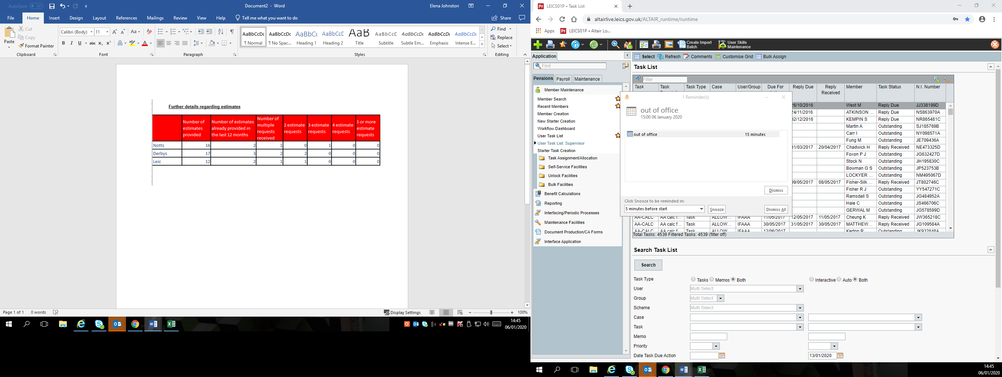

Nottinghamshire Metric Data For Quarter Ending 31.12.19
Category | 1992 | 2006 | 2015 | Modified
Active Members | 63 | 9 | 566 | 13
Pensioners Including Dependents | 807 | 21 | 15 | 56
New Pensioners Including Dependents | 3 | 3 | 1 | 1
Deferred Members | 54 | 228 | 126 | 48
New Deferred Members | 0 | 1 | 9 | 0
Opt Outs | 0 | 0 | 0 | 0
Deaths | 2 | 0 | 0 | 0
Transfers In | 0 | 0 | 0 | 0
Transfers Out | 0 | 0 | 0 | 0
Refunds | 0 | 0 | 0 | 0

Officers to Contact

Ian Howe – Pensions Manager - telephone (0116) 305 6945
Elena Johnston – Fire Pensions Team Manager - telephone (0116) 305 8216

